Lab 12

Submission: 11:59 PM February 14th, 2021

In Lab 11 I hope we all could run the code in Lab1_4C123. Also, I am assuming you all could run the Logic analyzer TExaSdisplay. In this lab 12, we will try to understand the code of Lab1 (in Lab1_4C123) to increase the rate of Task0 to 1000Hz and Task1 to 100Hz.

The code in Lab1 implements a simple fitness device which tracks and analyzes six tasks. Normally, one would use interrupts to create real-time periodic events. However, Lab1 ran without interrupts to illustrate the need for an operating system to manage multiple tasks that are only loosely connected. A very poorly constructed main program runs four of the tasks at about 10 times a second (10-Hz frequency) and the other two tasks at about once a second (1-Hz frequency). One of the best ways to see how the six tasks fit together is to understand the data being passed.

**Task0**: microphone input measuring RMS sound amplitude running at 10 Hz

Reads sound from microphone (ADC)

Sends SoundData to Task4

Sends SoundRMS to Task5

**Task1**: acceleration input measuring steps running at 10 Hz

Reads x,y,z acceleration (ADC)

Sends AlgorithmState to Task3

Sends Magnitude, EWMA to Task4

Sends Steps to Task5

**Task2**: light input measure average light intensity running at 1 Hz

Reads light from sensor (I2C)

Sends LightData to both Task4 and Task5

**Task3**: input from switches, output to buzzer running at 10 Hz

Inputs from Buttons (GPIO)

Sends PlotState to Task4

Outputs to Buzzer (PWM)

Outputs to LED (GPIO)

**Task4**: plotting output to LCD running at 10 Hz

Receives SoundData, Magnitude, EWMA, LightData, PlotState

Outputs to LCD (SSI)

**Task5**: numerical output to LCD running at 1 Hz

Receives SoundRMS, Steps, LightData

Outputs to LCD (SSI)

Now if you check the frequencies of different tasks in TExaSdisplay you might see the plots as following:

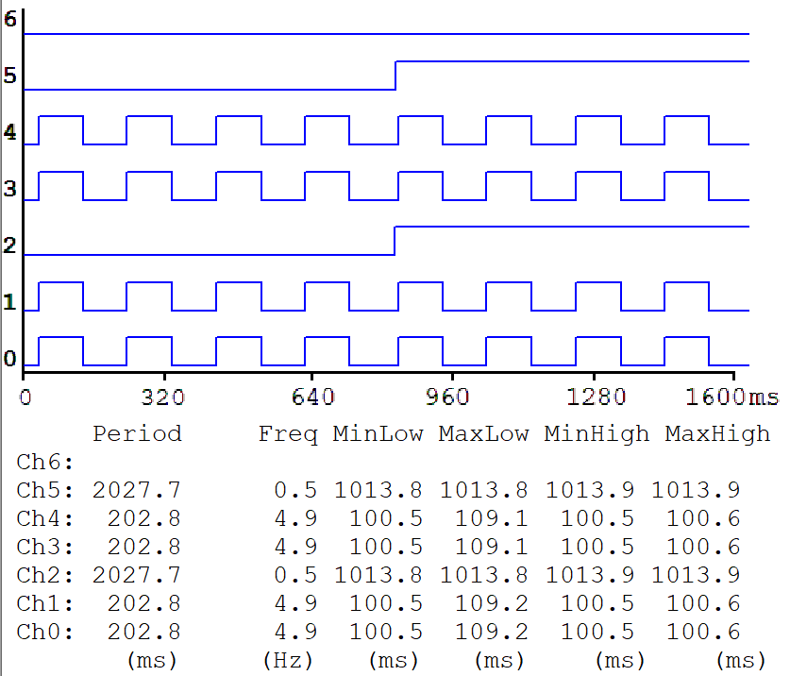

Here, you can see Task 0, 1, 3, and 4 has a period of 203ms (frequency 4.9 Hz) and Task 2, 4 shows a period of 2028ms (freq. of 0.5 Hz). However, in above explanation we can see Task 0, 1, 3, 4 are set to 10 Hz and Task 2, 4 are set to 1 Hz frequency. Typically, the software toggles the logic analyzer pin every time the thread runs. This results in a logic analyzer frequency that is 1/2 the thread frequency. i.e., a 5 Hz squarewave means the signal is toggled at 10 Hz.

Now if you increase the frequency of Task 0 from 10 to 100 Hz, you can see some losses of samples whenever other tasks run (or change in the clock edges). If more tasks run the losses of samples increase. That is the effect of managing several tasks without operating system. It also proves increasing number of tasks increase wastages of cycle time.

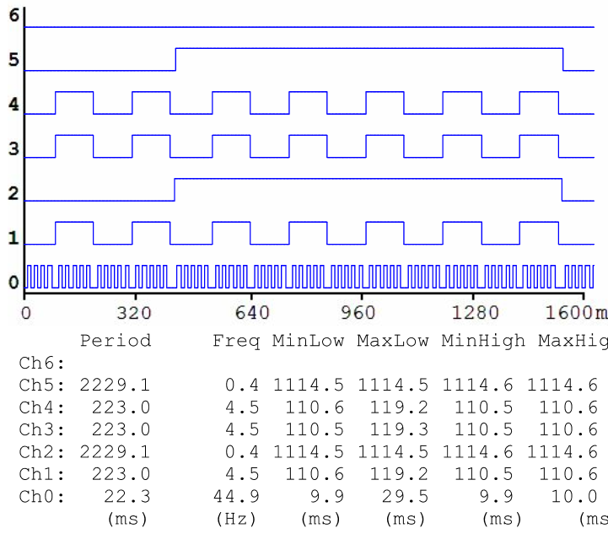

Lost data samples

Lab 12: Your assignment in Lab 12 is to increase the rate of Task 0 from 10 to 1000 Hz and Task 1 from 10 to 100 Hz. You need to submit the screenshot of TExaSdisplay for this new configuration for a time frame of 0~200ms and 0~3200ms. You need to do some trial and error to reduce the data sample losses. Also, submit the screenshot of change in code (from Lab11).